KRC-8510 Balanced Air Inflation System
Operating Instructions:
- Connect to air supply, no greater than 80 PSI
- Connect tire inflation lines to the tires before turning valve on (1-4 air lines)
- Slowly turn on valve (if valve is opened too quickly, the inflation protection system will detect the surge in pressure and activate)
- If system activates before complete tire inflation, close supply valve and reopen slowly
- Tires will inflate to approximately 40lbs and inflation system will activate 40 PSI pop-off valve briefly once tires are up to pressure at approximately 40 PSI (this will be an audible, small burst of air) NO more air will inflate tire
- Pressure on gauge does not reflect actual tire pressure until tires have been fully inflated
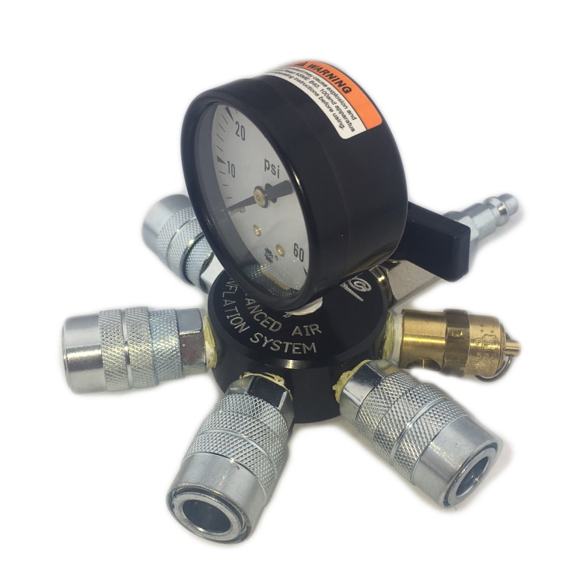
- Checking tire pressure during inflation. Turn off supply valve and gauge will read actual tire pressure
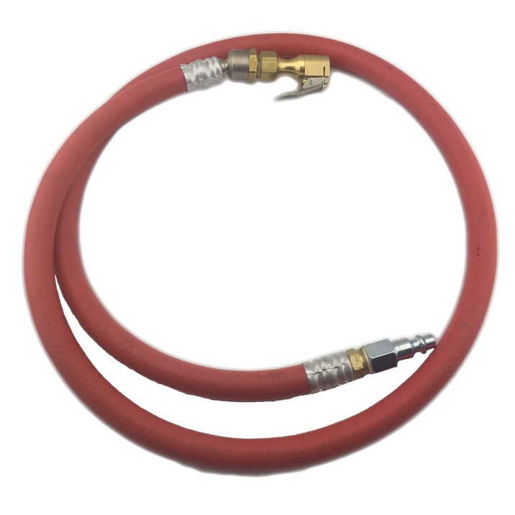
- Air supply is sufficient to inflate 1 or 4 tires in the same time period

KRC-8510 KRC-8512

